NOVENA TO ST. JOSEPH
9 - 18 MARCH 2021

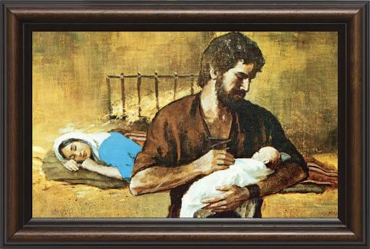
DAY ONE: St. Joseph, the Foster Father of Jesus
Saint Joseph, you were privileged to share in the mystery of the Incarnation as the foster-father of Jesus. In a direct manner you shared in the support, upbringing and protection of the Holy Family.
God gave you a heart that was filled with supernatural love, far deeper and more powerful than any natural father’s love could be.
What a wonderful and sublime vocation was yours to be the husband of Mary and the foster-father of Jesus. In your house at Nazareth and under your care, Jesus, the Redeemer of the world was preparing himself for his public ministry.
Joseph, I honour you and implore, through your powerful intercession, to obtain from the Divine Heart of Jesus all the graces necessary for my spiritual and temporal welfare, particularly the grace of a happy death and the special grace I now implore:
(mention your request ………………….).
Guardian of the Word incarnate, I am confident that your prayers, on my behalf, will be graciously heard before the throne of God. Amen.
THE ‘YEAR OF ST. JOSEPH’ PRAYER
To you, O blessed Joseph, do we come in our afflictions, and having implored the help of your most holy Spouse, we confidently invoke your patronage also.
Through that charity which bound you to the Immaculate Virgin Mother of God and through the paternal love with which you embraced the Child Jesus, we humbly beg you graciously to regard the inheritance which Jesus Christ has purchased by his Blood, and with your power and strength to aid us in our necessities.
O most watchful guardian of the Holy Family defend the chosen children of Jesus Christ; O most loving father, ward off from us every contagion of error and corrupting influence; O our most mighty protector, be kind to us and from heaven assist us in our struggle with the power of darkness.
As once you rescued the Child Jesus from deadly peril, so now protect God’s Holy Church from the snares of the enemy and from all adversity; shield, too, each one of us by your constant protection, so that, supported by your example and your aid, we may be able to live piously, to die in holiness, and to obtain eternal happiness in heaven. Amen.
For the intentions of our Holy Father Pope Francis
Our Father; Hail Mary; Glory be to the Father….
Saint Joseph, Patron of the Universal Church. Pray for us.

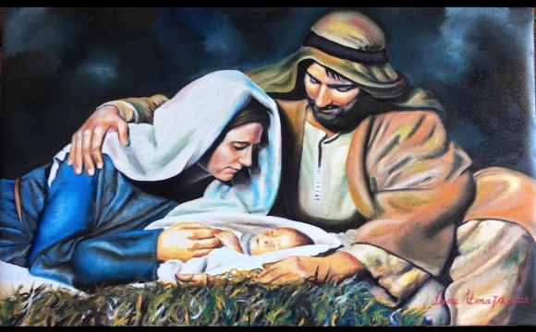

DAY TWO: St. Joseph, the Husband of Mary
Saint Joseph, I honour you as the true husband of Mary. Scripture says: 'Jacob begot Joseph, the husband of Mary, and of her was born Jesus who is called Christ' (Matt. 1:16). Your marriage to Mary was the way God chose to introduce Jesus to the world and God entrusted the care of Mary and Jesus to your care.
You were her faithful companion, support and comforter. Your love for Mary was based on your esteem for her as Mother of God.
Saint Joseph, I praise God for privilege He gave you of being the husband of Mary. Obtain for me the grace to love Jesus with all my heart, as you did, and to love Mary with some of the tenderness and loyalty with which you loved her.
Holy Saint Joseph, you are the faithful protector and intercessor of all who love and venerate you. Be my guide and my model through life that I may merit to die as you did in the arms of Jesus and Mary. I raise my heart to you to implore your powerful intercession in obtaining from the Divine Heart of Jesus all the graces necessary to my spiritual and temporal welfare, particularly the grace of a happy death, and the special grace I now implore.
(Mention your request……………………..).
Guardian of the Word Incarnate, I am confident that your prayers, on my behalf, will be graciously heard before the throne of God. Amen.
THE ‘YEAR OF ST. JOSEPH’ PRAYER
To you, O blessed Joseph, do we come in our afflictions, and having implored the help of your most holy Spouse, we confidently invoke your patronage also.
Through that charity which bound you to the Immaculate Virgin Mother of God and through the paternal love with which you embraced the Child Jesus, we humbly beg you graciously to regard the inheritance which Jesus Christ has purchased by his Blood, and with your power and strength to aid us in our necessities.
O most watchful guardian of the Holy Family defend the chosen children of Jesus Christ; O most loving father, ward off from us every contagion of error and corrupting influence; O our most mighty protector, be kind to us and from heaven assist us in our struggle with the power of darkness.
As once you rescued the Child Jesus from deadly peril, so now protect God’s Holy Church from the snares of the enemy and from all adversity; shield, too, each one of us by your constant protection, so that, supported by your example and your aid, we may be able to live piously, to die in holiness, and to obtain eternal happiness in heaven. Amen.
For the intentions of our Holy Father Pope Francis
Our Father; Hail Mary; Glory be to the Father….
Saint Joseph, Patron of the Universal Church. Pray for us.

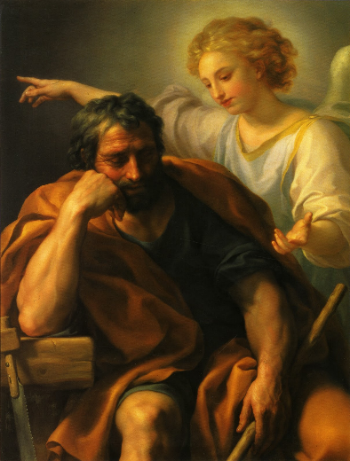
DAY THREE: St. Joseph, chosen by God the Father
Saint Joseph, you were the man chosen by God the Father. He selected you to be His representative on earth, and gave you all the graces and blessings you needed to raise the Son of God. You were an excellent example of integrity and righteousness who obeyed God in the face of severe humiliation and did the right thing before God, in the right manner.
We honour you because of the way in which you responded to God in obedience, integrity and a godly manner. Without question you trusted God even though you never knew all the details, but you acted in faith knowing that God would lead you to the next step.

Glorious Saint Joseph, spouse of the Immaculate Virgin, obtain for me a pure, humble, charitable mind, and perfect resignation to the Will of God. Be my guide and my model through life that I may merit to die as you did in the arms of Jesus and Mary.
Loving Saint Joseph, faithful follower of Jesus Christ, I raise my heart to you to implore your powerful intercession in obtaining from the Divine Heart of Jesus all the graces necessary for my spiritual and temporal welfare, particularly the grace of a happy death, and the special grace I now implore: (Mention your request…………..).
Guardian of the Word Incarnate, I feel confident that your prayers, on my behalf, will be graciously heard before the throne of God. Amen.
THE ‘YEAR OF ST. JOSEPH’ PRAYER
To you, O blessed Joseph, do we come in our afflictions, and having implored the help of your most holy Spouse, we confidently invoke your patronage also.
Through that charity which bound you to the Immaculate Virgin Mother of God and through the paternal love with which you embraced the Child Jesus, we humbly beg you graciously to regard the inheritance which Jesus Christ has purchased by his Blood, and with your power and strength to aid us in our necessities.
O most watchful guardian of the Holy Family defend the chosen children of Jesus Christ; O most loving father, ward off from us every contagion of error and corrupting influence; O our most mighty protector, be kind to us and from heaven assist us in our struggle with the power of darkness.
As once you rescued the Child Jesus from deadly peril, so now protect God’s Holy Church from the snares of the enemy and from all adversity; shield, too, each one of us by your constant protection, so that, supported by your example and your aid, we may be able to live piously, to die in holiness, and to obtain eternal happiness in heaven. Amen.
For the intentions of our Holy Father Pope Francis
Our Father; Hail Mary; Glory be to the Father….
Saint Joseph, patron of the Universal Church. Pray for us.

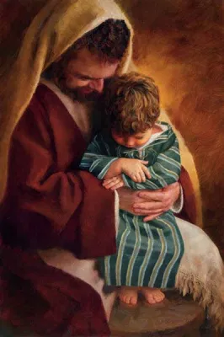
DAY FOUR: St. Joseph, the Faithful Servant of God
Saint Joseph, you were the faithful and just servant of God who listened, believed, obeyed and fulfilled God’s Will for what He had in mind for you. Your noble birth and ancestry, the graces and gifts, so generously poured out on you by God – all this was yours to serve God better. Every thought, word, and action of yours was a homage to the love and glory of the Incarnate Word. Your position in the Holy Family obliged you to lead by example, but besides being the foster-father of Jesus, you were also his disciple. You had the virtue of perfect devotedness, which marks a good servant. Faithful to your duties, you sacrificed everything unselfishly and cheerfully. Your entire life was one generous gift of unselfish devotedness as you worked without praise or reward. I thank God for your
privilege of being His faithful servant.
Holy Saint Joseph, obtain for me the grace to be as faithful a servant as you were. Help me to share, as you did, the perfect obedience of Jesus, who came not to do His Will, but the Will of His Father.
I raise my heart to you to implore your powerful intercession in obtaining from the Divine Heart of Jesus all the graces necessary for my spiritual and temporal welfare, particularly the grace of a happy death, and the special grace I now implore: (Mention your request…..)
Guardian of the Word Incarnate, I feel confident that your prayers, on my behalf, will be graciously heard before the throne of God. Amen.
THE ‘YEAR OF ST. JOSEPH’ PRAYER
To you, O blessed Joseph, do we come in our afflictions, and having implored the help of your most holy Spouse, we confidently invoke your patronage also.
Through that charity which bound you to the Immaculate Virgin Mother of God and through the paternal love with which you embraced the Child Jesus, we humbly beg you graciously to regard the inheritance which Jesus Christ has purchased by his Blood, and with your power and strength to aid us in our necessities.
O most watchful guardian of the Holy Family defend the chosen children of Jesus Christ; O most loving father, ward off from us every contagion of error and corrupting influence; O our most mighty protector, be kind to us and from heaven assist us in our struggle with the power of darkness.
As once you rescued the Child Jesus from deadly peril, so now protect God’s Holy Church from the snares of the enemy and from all adversity; shield, too, each one of us by your constant protection, so that, supported by your example and your aid, we may be able to live piously, to die in holiness, and to obtain eternal happiness in heaven. Amen.
For the intentions of our Holy Father Pope Francis
Our Father; Hail Mary; Glory be to the Father….
Saint Joseph, patron of the Universal Church. Pray for us.

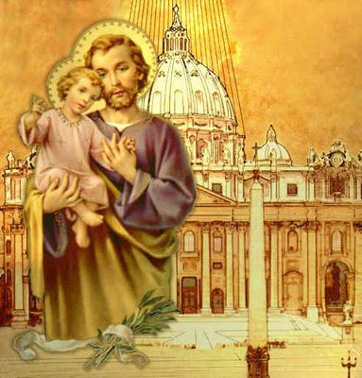
DAY FIVE: Saint Joseph, the Patron of the Universal Church
O Glorious Saint Joseph, you were chosen by God to be the foster father of Jesus, most pure spouse of Mary, ever Virgin, and the head of the Holy Family. You have been chosen by Christ’s Vicar as the heavenly Patron and Protector of the Church founded by Christ.
Protect our Holy Father, Pope Francis, and all bishops and priests united to him. Be also the protector of all who work for the spreading of God’s Kingdom despite many difficulties and grant, through the merits of Jesus Christ, salvation for all who believe in God. Dear Saint Joseph be my protector and guide along the path to eternal life. Obtain for me purity of heart and a love for the spiritual life. After your example, let all my actions be directed to the greater glory of God. Finally, pray for me that I may share in the peace and joy of your holy death.
Loving Saint Joseph, faithful follower of Jesus Christ, I raise my heart to you to implore your powerful intercession in obtaining from the Divine Heart of Jesus all the graces necessary for my spiritual and temporal welfare, particularly the grace of a happy death, and the special grace I now implore: (Mention your request…………………..).
Guardian of the Word Incarnate, I feel confident that your prayers in my behalf will be graciously heard before the throne of God. Amen.
THE ‘YEAR OF ST. JOSEPH’ PRAYER
To you, O blessed Joseph, do we come in our afflictions, and having implored the help of your most holy Spouse, we confidently invoke your patronage also.
Through that charity which bound you to the Immaculate Virgin Mother of God and through the paternal love with which you embraced the Child Jesus, we humbly beg you graciously to regard the inheritance which Jesus Christ has purchased by his Blood, and with your power and strength to aid us in our necessities.
O most watchful guardian of the Holy Family defend the chosen children of Jesus Christ; O most loving father, ward off from us every contagion of error and corrupting influence; O our most mighty protector, be kind to us and from heaven assist us in our struggle with the power of darkness.
As once you rescued the Child Jesus from deadly peril, so now protect God’s Holy Church from the snares of the enemy and from all adversity; shield, too, each one of us by your constant protection, so that, supported by your example and your aid, we may be able to live piously, to die in holiness, and to obtain eternal happiness in heaven. Amen.
For the intentions of our Holy Father Pope Francis
Our Father; Hail Mary; Glory be to the Father….
Saint Joseph, patron of the Universal Church. Pray for us.

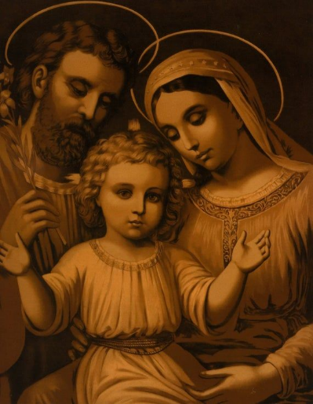
DAY SIX: St. Joseph, the Patron of Families
Saint Joseph, I thank God for accepting to be the head of the Holy Family where you sanctified family life by your example. You were their protector, counsellor and consolation in every need. You cherished all the experiences common to family life and the sacred memories of the life, sufferings and joys in the company of Jesus and Mary. In your loving fatherliness and unfailing intercession, you are the patron and intercessor of families, and you deserve a place in every home. Make our homes sanctuaries of prayer, of love, of patient sacrifice and of work.
O Most holy Joseph, take my family under your fatherly protection and care and be for them a strong defender against all who seek to harm us. As a family may we always turn to you as our inspiration, counsellor and guide. Obtain for me, from God, that my family life may always be in accordance with God’s Holy Will. I also pray for all families where your help is needed. Obtain for us, great Saint Joseph, that we may faithfully fulfil our duties towards God in good times and in times of difficulty; that we may be watchful in avoiding every occasion of sin so as to live holy lives and leave this world perfectly resigned to the will of God. Mercifully turn your eyes to families
who have seen everything in life taken away from them and obtain for them the dignity of a job and the serenity of a home.
Loving Saint Joseph, faithful follower of Jesus Christ, I raise my heart to you to implore your powerful intercession in obtaining from the Divine Heart of Jesus all the graces necessary for my spiritual and temporal welfare, particularly the grace of a happy death, and the special grace I now implore: (Mention your request……….).
Guardian of the Word Incarnate, I feel confident that your prayers on my behalf will be graciously heard before the throne of God. Amen.
THE ‘YEAR OF ST. JOSEPH’ PRAYER
To you, O blessed Joseph, do we come in our afflictions, and having implored the help of your most holy Spouse, we confidently invoke your patronage also.
Through that charity which bound you to the Immaculate Virgin Mother of God and through the paternal love with which you embraced the Child Jesus, we humbly beg you graciously to regard the inheritance which Jesus Christ has purchased by his Blood, and with your power and strength to aid us in our necessities.
O most watchful guardian of the Holy Family defend the chosen children of Jesus Christ; O most loving father, ward off from us every contagion of error and corrupting influence; O our most mighty protector, be kind to us and from heaven assist us in our struggle with the power of darkness.
As once you rescued the Child Jesus from deadly peril, so now protect God’s Holy Church from the snares of the enemy and from all adversity; shield, too, each one of us by your constant protection, so that, supported by your example and your aid, we may be able to live piously, to die in holiness, and to obtain eternal happiness in heaven. Amen.

For the intentions of our Holy Father Pope Francis
Our Father; Hail Mary; Glory be to the Father….
Saint Joseph, patron of the Universal Church. Pray for us.

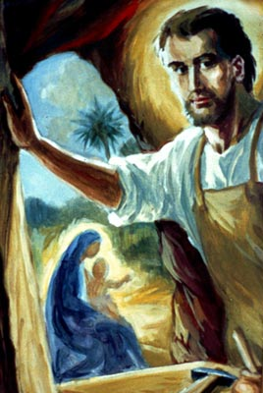
DAY SEVEN: St. Joseph, the Patron of Workers
Saint Joseph, patron of all working people, thank you for the opportunity to build up God’s kingdom through the work of our hands. Help me to be conscientious in my work and to do everything in in a spirit of thankfulness and joy, mindful of the gifts I have received from God. Allow me to work in peace, patience and moderation.
During your life you worked humbly and diligently and was able to pass on your skills to Jesus who was entrusted to your care. I ask you to obtain for me the grace to respect the dignity of labour. Teach me to work for God and with God in the spirit of humility and prayer, as you did. I also pray to you for those who are out of work and have been adversely affected the Corona virus pandemic and who are struggling now to support their families. We honour you as the patron of workers and therefore ask you to implore on our behalf that in a more just and fair world, all those who are willing to work may be given the opportunity of being able to financially support themselves and their families.

Loving Saint Joseph, faithful follower of Jesus Christ, I raise my heart to you to implore your powerful intercession in obtaining from the Divine Heart of Jesus all the graces necessary for my spiritual and temporal welfare, particularly the grace of a happy death, and the special grace I now implore: (Mention your request ……..).
Guardian of the Word Incarnate, I feel confident that your prayers in my behalf will be graciously heard before the throne of God. Amen.
THE ‘YEAR OF ST. JOSEPH’ PRAYER
To you, O blessed Joseph, do we come in our afflictions, and having implored the help of your most holy Spouse, we confidently invoke your patronage also.
Through that charity which bound you to the Immaculate Virgin Mother of God and through the paternal love with which you embraced the Child Jesus, we humbly beg you graciously to regard the inheritance which Jesus Christ has purchased by his Blood, and with your power and strength to aid us in our necessities.
O most watchful guardian of the Holy Family defend the chosen children of Jesus Christ; O most loving father, ward off from us every contagion of error and corrupting influence; O our most mighty protector, be kind to us and from heaven assist us in our struggle with the power of darkness.
As once you rescued the Child Jesus from deadly peril, so now protect God’s Holy Church from the snares of the enemy and from all adversity; shield, too, each one of us by your constant protection, so that, supported by your example and your aid, we may be able to live piously, to die in holiness, and to obtain eternal happiness in heaven. Amen.
For the intentions of our Holy Father Pope Francis
Our Father; Hail Mary; Glory be to the Father….
Saint Joseph, patron of the Universal Church. Pray for us.

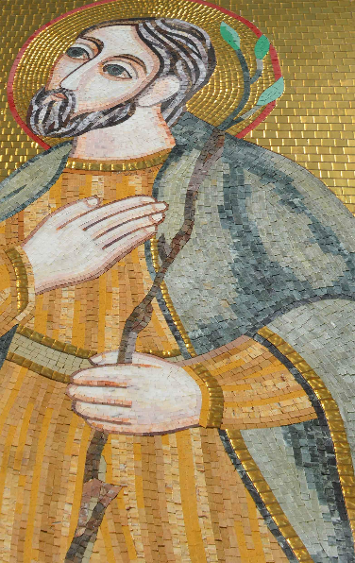
DAY EIGHT: St. Joseph, the Friend of those who are Suffering
Saint Joseph, you experienced your fair share of suffering that is the lot of most human beings. You were kind and sympathetic towards those in need and people in distress found in you a faithful and understanding friend.
Having been so intimately united with Jesus and Mary in your life, even now your intercession together with theirs is, I believe, most powerful. Obtain for me the grace to bear my sufferings patiently and that I may unite my pain and suffering to your own and that of Mary and Jesus. Look kindly on all who are suffering at this time and ease their pain. Preserve the elderly from loneliness and grant that no one might be left in desperation from abandonment and discouragement. Comfort those who are the frailest, encourage those who have lost all hope and intercede for the poor. With the Virgin Mother, beg the Lord to liberate the world from every form of pandemic.
Loving Saint Joseph, faithful follower of Jesus Christ, I raise my heart to you to implore your powerful intercession in obtaining from the Divine Heart of Jesus all the graces necessary for my spiritual and temporal welfare, particularly the grace of a happy death, and the special grace I now implore: (Mention your request …………….).
Guardian of the Word Incarnate, I feel confident that your prayers on my behalf will be graciously heard before the throne of God. Amen.
THE ‘YEAR OF ST. JOSEPH’ PRAYER
To you, O blessed Joseph, do we come in our afflictions, and having implored the help of your most holy Spouse, we confidently invoke your patronage also.
Through that charity which bound you to the Immaculate Virgin Mother of God and through the paternal love with which you embraced the Child Jesus, we humbly beg you graciously to regard the inheritance which Jesus Christ has purchased by his Blood, and with your power and strength to aid us in our necessities.
O most watchful guardian of the Holy Family defend the chosen children of Jesus Christ; O most loving father, ward off from us every contagion of error and corrupting influence; O our most mighty protector, be kind to us and from heaven assist us in our struggle with the power of darkness.
As once you rescued the Child Jesus from deadly peril, so now protect God’s Holy Church from the snares of the enemy and from all adversity; shield, too, each one of us by your constant protection, so that, supported by your example and your aid, we may be able to live piously, to die in holiness, and to obtain eternal happiness in heaven. Amen.
For the intentions of our Holy Father Pope Francis
Our Father; Hail Mary; Glory be to the Father….
Saint Joseph, patron of the Universal Church. Pray for us.

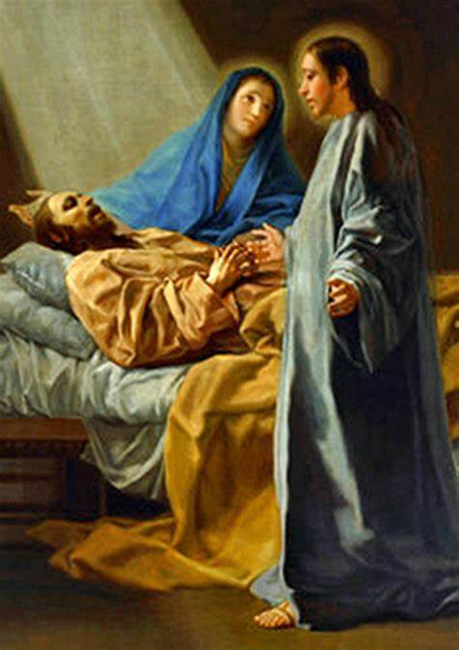
DAY NINE: St. Joseph, the Patron of a Happy Death
Saint Joseph, I call upon you as the “Patron of a Happy Death” to help me prepare for the hour of my death. I believe that you died a happy and holy death because Jesus and Mary were at your side and your death reflected the holiness of your life. I pray, through your intercession, to be spared from a sudden and unprepared death. Saint Joseph, I thank God for your privilege of being able to die in the arms of Jesus and Mary. May I, too, accept death in the spirit of resignation to God's Holy Will, and die, as you did, in the arms of Jesus and Mary. I call upon you Saint Joseph, together with all who are dear to me and all that belong to me, for your powerful intercession. I beg of you, by your love for Jesus and Mary, not to abandon me during life and to assist me at the hour of my death.

Jesus, Mary and Joseph, I give you my heart and my soul.
Jesus, Mary and Joseph, assist me in my last agony.
Jesus, Mary and Joseph, may I breathe forth my soul in peace with you. Amen.

Loving Saint Joseph, faithful follower of Jesus Christ, I raise my heart to you to implore your powerful intercession in obtaining from the Divine Heart of Jesus all the graces necessary for my spiritual and temporal welfare, particularly the grace of a happy death, and the special grace I now implore: (Mention your request …..).
Guardian of the Word Incarnate, I feel confident that your prayers in my behalf will be graciously heard before the throne of God. Amen.
THE ‘YEAR OF ST. JOSEPH’ PRAYER
To you, O blessed Joseph, do we come in our afflictions, and having implored the help of your most holy Spouse, we confidently invoke your patronage also.
Through that charity which bound you to the Immaculate Virgin Mother of God and through the paternal love with which you embraced the Child Jesus, we humbly beg you graciously to regard the inheritance which Jesus Christ has purchased by his Blood, and with your power and strength to aid us in our necessities.
O most watchful guardian of the Holy Family defend the chosen children of Jesus Christ; O most loving father, ward off from us every contagion of error and corrupting influence; O our most mighty protector, be kind to us and from heaven assist us in our struggle with the power of darkness.
As once you rescued the Child Jesus from deadly peril, so now protect God’s Holy Church from the snares of the enemy and from all adversity; shield, too, each one of us by your constant protection, so that, supported by your example and your aid, we may be able to live piously, to die in holiness, and to obtain eternal happiness in heaven. Amen.
For the intentions of our Holy Father Pope Francis
Our Father; Hail Mary; Glory be to the Father….
Saint Joseph, patron of the Universal Church. Pray for us.

